Datapath Operators using Verilog Syntax
Last update: 07 Dec 2005
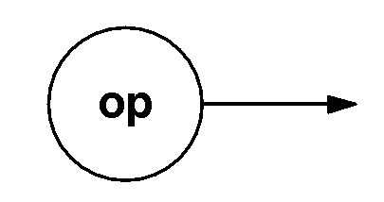
op | Meaning | Examples
N | Output = N (N is a constant) | 3 (decimal 3)  ’hF2 (hexadecimal)  ’b1101_1001 (binary)

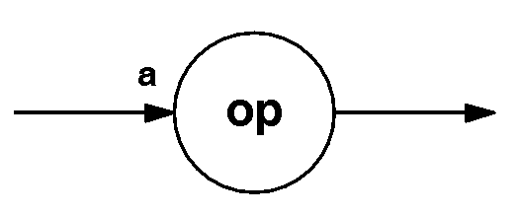
op | Meaning | Examples
a + N | Output = Input plus N (N is a constant integer)
a − N | Output = Input minus N (N is a constant integer)
~a | Output = Bitwise complement of input | 4’b1011 as input yields 4’b0100 as output
&a | Output = Bitwise AND of all input bits | 4’b1011 as input yields 1’b0 as output; 4’b1111 as input yields 1’b1 as output
|a | Output = Bitwise OR of all input bits | 4’b1011 as input yields 1’b1 as output; 4’b0000 as input yields 1’b0 as output
^a | Output = Bitwise EXOR of all input bits (output is 1 when the input has an odd number of bits whose value is one) | 4’b1011 as input yields 1’b1 as output; 4’b1010 as input yields 1’b0 as output
!a | Output = 1 when the input is 0, otherwise 0 (expects single-bit inputs created by the relational operators below, i.e., equal-to, not-equal-to, etc.)
a == N | Output = 1 when the input is equal to N
a != N | Output = 1 when the input is not equal to N
a > N | Output = 1 when the input is greater than N
a >= N | Output = 1 when the input is greater than or equal to N
a < N | Output = 1 when the input is less than N
a <= N | Output = 1 when the input is less than or equal to N
a && N | Output = 1 when input and N are both 1, otherwise 0 (expects single-bit inputs created by the relational operators above, i.e., equal-to, not-equal-to, etc.)
a || N | Output = 1 when either input or N is 1, otherwise 0 (expects single-bit inputs created by the relational operators above, i.e., equal-to, not-equal-to, etc.)
a & N | Output = bitwise AND of the input and N
a | N | Output = bitwise OR of the input and N
a ^ N | Output = bitwise EXOR of the input value and N
a * N | Output = product of the input and N
a / N | Output = a divided by N
a % N | Output = a modulo N
a ** N | Output = a raised to the N power
a<<N | Output = Left shift by N places; fill right side with zeros
a>>N | Output = Right shift by N places; fill left side with zeros
a>>>N | Output = Arithmetic right shift by N places; fill left side with most-significant bit (sign bit) of input
a[ r ] | Output = Selected bitrange of input | Operator [2] picks out bit number 2 of the input bus; operator [2:0] picks out the least-significant three bits of the input bus
{N,a} | Output = Numerical constant concatenated with input (can interchange order, or use additional constants; see examples); output is wider than input | {4’b1101,a} – put a four bit constant to the left of input a  {a,8’d0} – put eight bits of zero to the right of a  {2’d0,a,2’d0} – embed a in the middle of four bits of zero
{N {a }} | Output = Input replicated N times | Suppose input a is a single-bit signal, then operator {5{ a}} will create a five-bit bus whose value is aaaaa

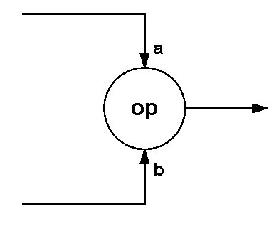

op | Meaning | Examples
a == b | Output = 1 when the input values are equal
a != b | Output = 1 when the input values are not equal
a < b | Output = 1 when input a is less than input b
a <= b | Output = 1 when input a is less than or equal to input b
a > b | Output = 1 when input a is greater than input b
a >= b | Output = 1 when input a is greater than or equal to input b
a && b | Output = 1 when both inputs are 1, otherwise 0 (expects single-bit inputs created by the relational operators above, i.e., equal-to, not-equal-to, etc.)
a || b | Output = 1 when either input is 1, otherwise 0 (expects single-bit inputs created by the relational operators above, i.e., equal-to, not-equal-to, etc.)
a & b | Output = bitwise AND of the input values
a | b | Output = bitwise OR of the input values
a ^ b | Output = bitwise EXOR of the input values
a + b | Output = sum of the input values
a − b | Output = a minus b
a * b | Output = product of the input values
a / b | Output = a divided by b
a % b | Output = a modulo b
a ** b | Output = a raised to the b power
{ a,b } | Output = concatenation of input a and input b | If a is a 3-bit bus with value a₂a₁a₀ and b is a 2-bit bus with value b₁b₀, then the output is a five-bit bus with value a₂a₁a₀b₁b₀

